Design Document

Table of Contents

**1. System Overview and Architecture 4**

**2. Class Diagrams 5**

**3. Use Case Specifications 6**

Use Case Name: User signs into ATM 6

Use Case Name: Creating Account 6

Use Case Name: Deleting Account 7

Use Case Name: User uses ATM to deposit money 7

Use Case Name: User uses ATM to withdraw money 8

Use Case Name: Teller Logins User Account 8

Use Case Name: User uses ATM to transfer money 9

Use Case Name: Teller adds additional user to an account 9

Use Case Name: Change Pin 10

Use Case Name: Account Admin Status Transfer 10

Use Case Name: Forget Password 11

Use Case Name: Delete User from an Account 11

Use Case Name: Show Account Total 12

Use Case Name: User Logouts of ATM 12

Use Case Name: ATM Login Verification by Server 13

Use Case Name: ATM Logout Verification by Server 13

Use Case Name: ATM Withdrawal Transaction 14

Use Case Name: ATM Deposit Transaction 14

Use Case Name: ATM Transfer Transaction 15

Use Case Name: Teller Login Verification by Server 16

Use Case Name: Teller Create New User 16

Use Case Name: Teller Login to User by Server 17

Use Case Name: Teller Reset User Password by Server 17

Use Case Name: Teller Create Account by Server 18

Use Case Name: Teller Change User Pin by Server 18

Use Case Name: Teller Withdrawal Transaction 19

Use Case Name: Teller Deposit Transaction 19

Use Case Name: Teller Transfer Transaction 20

Use Case Name: Teller Add User to Account by Server 21

Use Case Name: Teller Delete Account by Server 21

Use Case Name: Teller Remove User from Account by Server 22

Use Case Name: Teller Transfer Admin by Server 23

Use Case Name: Teller Admin Add Teller by Server 23

Use Case Name: Teller Admin Remove Teller by Server 24

Use Case Name: Teller Admin View Logs by Server 24

Use Case Name: Admin Teller Login 25

Use Case Name: Admin Teller Adds Teller 25

Use Case Name: Admin Teller Deletes Teller 26

Use Case Name: Admin Teller Creates User 26

Use Case Name: Admin Teller Opens Logs 27

Use Case Name: Teller Logs Out 27

Use Case Name: Teller Logs Out of User’s Account 28

Use Case Name: Teller Refers to ATM 28

Use Case Name: Teller Login 29

**4. Use Case Diagrams 30**

1. Overall Use Case Diagram: 30

2. Teller Use Case Diagram: 30

3. ATM Use case Diagram: 31

**5. Sequence Diagrams 32**

1. ATM Transfer Money Sequence Diagram 32

2. ATM Withdraw Money Sequence Diagram 33

3. Teller Create New User Sequence Diagram 34

4. Teller Add User to Account 35

5. Teller Change Pin 36

6. Teller Create Account 37

7. Teller Delete Account 38

8. Teller Remove User from Account 39

9. Teller Rest User Password 40

10. Teller Transfer User Account Admin to Another 41

11. Teller Admin Add Teller 42

**6. User Interface Design 43**

1. ATM UI Design 43

2. Teller application UI Design 44

# System Overview and Architecture

This B.S. consists of three main parts: ATM, Teller application, and the Server. Among them, ATM and Teller applications are the clients, which could be zero or multiple instances, making requests to the Server to establish the connections. The Server is a multi-threaded application which takes every single connection request from the client and creates a new thread to handle it.

This setup simulates the two common situations in a normal bank. For the first situation, a user needs to go to the ATM to withdraw, deposit, and transfer money, interacting with the ATM application. In the second case, a bank teller uses the Teller application to assist customers with various account management tasks, including creating new accounts and users, modifying account details, and addressing access issues like forgotten passwords. The bank teller also facilitates more complex operations such as account deletion, user additions or removals, transferring account administration rights, and changing PINs, ensuring clients' banking needs are met efficiently. Details can be found in the section of Use Case Specifications and Use Case Diagrams.

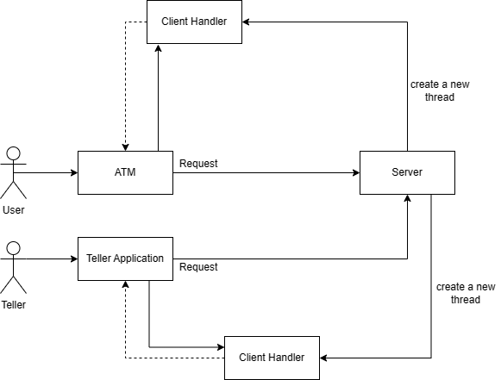

# Class Diagrams

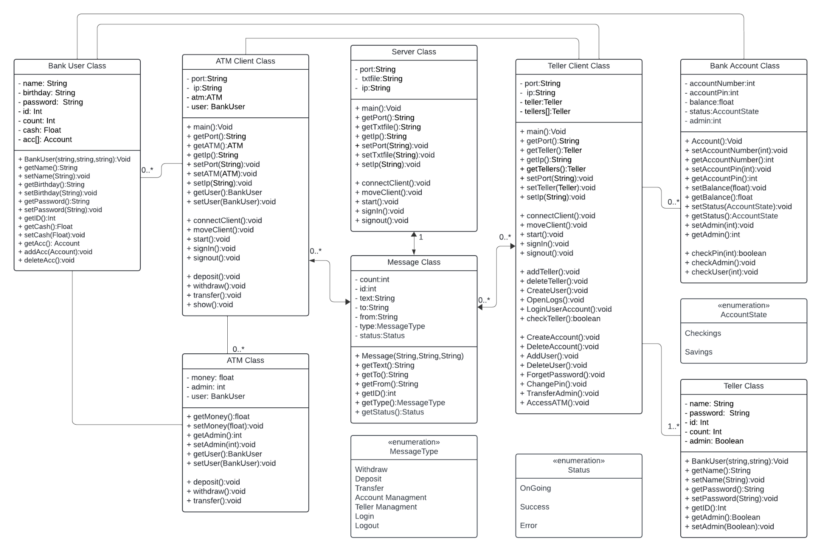

# Use Case Specifications

Use Case ID: 001

## Use Case Name: User signs into ATM

Relevant Requirements: 3.1.4.6

Primary Actor: User

Pre-Conditions: A teller has already created an account for the user.

Post-Conditions: The user will be able to access their bank user account using their credentials.

Basic Flow/Main Scenario:

1. Users enter their username and password onto the login.
2. The system validates the information given from the login.
3. System responds by allowing the user to login to their bank user account.
4. Users access the ATM client.
5. ATM application presents account information, withdraw, deposit, transfer, and logout options.

Alternative flow:

* If the user puts in any of the following information incorrectly, the system does not log the user in and asks them to try again.
* If the user forgets the password, they should ask the teller in person to reset the password in order to log in.

Exceptions:

* If a user attempts to sign into an account that does not exist, an error message is displayed.

Related Use Cases:

* N/A

_____________________________________________________________________________________

Use Case ID: 002

## Use Case Name: Creating Account

Relevant Requirements: 3.1.3.13

Primary Actor: Teller

Pre-conditions:

* Teller has logged in to the Teller application.
* Teller receives a request to create an account from the user.

Post-conditions:

* The new account (either checking or saving) is successfully created in the system.
* The user is provided with a randomly generated PIN.
* Teller application sends a request to the server application.

Basic Flow or Main Scenario:

1. Teller selects the option to create a new account.
2. System prompts the teller to specify the type of account (checking or saving).
3. Teller chooses the account type.
4. System generates a random PIN for the account.
5. System displays a confirmation message indicating account number, pin, and type.

Extensions or Alternate Flows:

* If any required customer information is missing or invalid, the system prompts the teller to correct the details.
* If there is a system error during the account creation process, the teller is alerted with an appropriate error message.

Exceptions:

* If the system fails to generate a random PIN, the teller is prompted to retry.

Related Use Cases:

* Account modification, Account deletion.

_____________________________________________________________________________________

Use Case ID: 003

## Use Case Name: Deleting Account

Relevant Requirements: 3.1.3.12

Primary Actor: Teller

Pre-conditions:

* Teller has logged in to the Teller application.
* Teller receives a request to delete an account from the user.

Post-conditions:

* The account has been successfully deleted from the system.
* A confirmation message is displayed to the teller.
* Teller application sends a request to the server application.

Basic Flow or Main Scenario:

1. Teller enters user id to access user’s account information.
2. Teller selects the option to delete an account.
3. The system displays a list of accounts.
4. Teller chooses an account from the list.
5. The system displays the balance of the account, and withdraw and transfer options to handle the balance.
6. After handling the balance, the teller chooses ok.
7. The system prompts the teller to confirm the deletion.
8. Teller confirms the deletion.

Extensions or Alternate Flows:

* If the system cannot validate the account details provided by the teller, it prompts the teller to re-enter the information.
* If the teller decides to cancel the deletion process at any step, the system returns to the previous state, and no account deletion occurs.

Exceptions:

* In case of technical issues or errors during the deletion process, an error message is displayed, and the teller is prompted to contact technical support.
* If the account to be deleted has pending transactions or unresolved issues, the system alerts the teller and provides instructions on resolving these matters before proceeding with the deletion.

Related Use Cases:

* Account creation
* ATM or Teller window, Bank User chooses Teller

_________________________________________________________________________

Use Case ID: 004

## Use Case Name: User uses ATM to deposit money

Relevant Requirements: 3.1.4.1

Primary Actor: ATM

Pre-Conditions: A User must have already signed into their account.

Post-Conditions: The money the user has deposited is added to the total amount in their account.

Basic Flow/Main Scenario:

1. The bank user selects to deposit money to an account.
2. The system responds by asking for the amount to deposit.
3. The bank user chooses a specific amount to deposit.
4. The system adds the amount to the total amount in their account.

Alternative flow:

* If the user attempts to deposit zero dollars, the system will not deposit money and tells the user to choose a nonzero amount.

Exceptions:

* If the user attempts to deposit money into an account that doesn’t exist, the system will display an error message.

Related Use Cases:

* ATM or Teller window, bank user chooses ATM

_____________________________________________________________________________________

Use Case ID: 005

## Use Case Name: User uses ATM to withdraw money

Relevant Requirements: 3.1.4.1

Primary Actor: ATM

Pre-Conditions: Bank User must have already signed into their account.

Post-Conditions: The ATM service will have withdrawn a specific amount of money the bank user has requested out of their account.

Basic Flow/Main Scenario:

1. The bank user selects to withdraw money from their account.
2. The system responds by asking the user the amount of money to withdraw.
3. The bank user chooses a specific amount to withdraw.
4. The system takes that amount of money out of the user’s account to give to the user.

Alternative flow:

* If the bank user attempts to withdraw from an account that holds zero balance, the system does not perform the action and tells the user there is no money in the account.
* If the bank user attempts to withdraw more money than what the account holds, the system tells the user that they are withdrawing more than what the account has currently.

Exceptions:

* If the user attempts to withdraw from an account that doesn’t exist, an error message is displayed.

Related Use Cases:

* ATM or Teller window, bank user chooses ATM

_____________________________________________________________________________________

Use Case ID: 006

## Use Case Name: Teller Logins User Account

Relevant Requirements: 3.1.3.5

Primary Actor: ATM

Pre-Conditions:

* Teller has logged in to the Teller application.

Post-Conditions:

* Teller accesses user’s account information.

Basic Flow/Main Scenario:

1. Teller chooses option ‘login user account’.
2. Teller enters username.

Alternative flow:

* If the teller enters a username that does not exist, the system prompts the teller that the user name does not exist.
* If the teller entered the wrong username and entered the wrong user’s account information, the teller logs out from that user’s account information.

Exceptions:

* When the teller client encounters issues connecting to the server, user account log in requests are not completed.

Related Use Cases:

* Admin teller logins user account

_____________________________________________________________________________________

Use Case ID: 007

## Use Case Name: User uses ATM to transfer money

Relevant Requirements: 3.1.4.1

Primary Actor: ATM

Pre-Conditions: The User must have already signed into their account.

Post-Conditions: The ATM service will have transferred a specific amount of money from one account to another.

Basic Flow/Main Scenario:

1. The bank user selects to transfer money to another account.
2. The system responds by having the user select the account they want to transfer money to as well as the amount of money to transfer.
3. The bank user chooses an account along with the amount of money to transfer.
4. The system transfers that amount from the origin account to the selected account.

Alternative flow:

* If the amount of money being transferred is zero, the system tells the user to choose a specific amount of money
* If the amount of money being transferred is more than what the account transferring has, the system tells the user that the account does not have the amount specified to transfer.

Exceptions:

* If the account money is being transferred to or from does not exist, an error message is displayed.

Related Use Cases:

* User signs into ATM

_____________________________________________________________________________________

Use Case ID: 008

## Use Case Name: Teller adds additional user to an account

Relevant Requirements: 3.1.3.13

Primary Actor: Teller

Pre-Conditions:

* Teller has logged in to the Teller application.
* Before a new bank user is added to an account, it must be established who is the highest-status user on the account.

Post-Conditions:

1. A new user is added to the account.
2. The account number where the new user was added and the user’s name are displayed.
3. Teller application send a request to the server application

Basic Flow/Main Scenario:

1. The teller receives a request from an account’s admin user to add a new user to the account.
2. The teller accesses the account information of the admin user through the user's id.
3. A list of accounts owned by the user appears, and accounts for which the user has admin status are displayed on the right.
4. The teller adds a new user by entering a new user id.
5. When the teller enters the id of the user to be added, the account number and name of the user to be added are checked one more time.
6. After addition is complete, the account number under which the new user was added and the added user name are displayed.

Alternative flow:

* A request to add a new user from a user who does not have admin status for the account cannot be sent to the teller.
* Teller cannot add new users to an account of an user without admin status.

Exceptions:

* If the information of the newly added user cannot be confirmed from a server, a message indicating that the user’s information is not found is displayed.

Related Use Cases:

* Teller Logins User Account

_____________________________________________________________________________________

Use Case ID: 009

## Use Case Name: Change Pin

Relevant Requirements: 3.1.3.3

Primary Actor: Teller

Pre-Conditions:

* Teller has logged in to the Teller application.

Post-Conditions:

* A new pin number is created for the corresponding account.
* Teller application send a request to the server application

Basic Flow/Main Scenario:

1. The user requests the teller to change the account pin number.
2. The teller enters the user’s id to access the user’s account information.
3. The teller is prompted to enter a new pin.
4. A message that the pin change has been completed is displayed.

Alternative flow:

* If the teller enters the previous pin number, the system prompts the user to enter a new pin.

Exceptions:

* The system accepts only numbers for the new pin.

Related Use Cases: Teller window

_____________________________________________________________________________________

Use Case ID: 010

## Use Case Name: Account Admin Status Transfer

Relevant Requirements: 3.1.3.6

Primary Actor: Teller

Pre-Conditions:

* Teller has logged in to the Teller application.
* Teller receives a request to transfer account admin status from the account’s admin user.

Post-Conditions:

* The admin user status of the account has been transferred.
* Teller applications send a request to the server application.

Basic Flow/Main Scenario:

1. The teller enters the user’s id to access the account information.
2. The teller selects an account to change admin status.
3. System displays a list of users belonging to that account.
4. The teller selects a user, and a message is displayed confirming that the selected is correct.
5. The teller selects it in the confirmation message.
6. The admin user is changed.

Alternative flow:

* Users who do not have admin status do not have the option to request an admin status transfer to a teller within their account.
* If the teller cannot confirm the new admin user requested from the admin user, the transfer is not completed.

Exceptions:

* If the teller enters a user id that does not exist, a message indicating that the user does not exist is displayed.

Related Use Cases:

* Teller adds a user to an account.

_____________________________________________________________________________________

Use Case ID: 011

## Use Case Name: Forget Password

Relevant Requirements: 3.1.3.10

Primary Actor: Teller

Pre-Conditions:

* Teller has logged in to the Teller application.
* User requests the teller to change the password.

Post-Conditions:

* The new password has been created.
* Teller application send a request to the server application

Basic Flow/Main Scenario:

1. The teller enters the user id to access user’ account information.
2. The teller chooses the option to forget the password.
3. The teller enters a birthday and new password.
4. A confirmation message for birthday and new password is displayed, and if the teller clicks ok, the change will be completed.

Alternative flow:

* If the teller enters a birthday that does not match the user information, a message indicating that the birthday does not match with user information is displayed
* If the teller enters a password that exceeds the allowed password length, the password will not be entered.

Exceptions:

* If the teller enters a user id that does not exist, a message indicating that the user does not exist is displayed.

Related Use Cases:

* Teller Logins User Account

_____________________________________________________________________________________

Use Case ID: 012

## Use Case Name: Delete User from an Account

Relevant Requirements: 3.1.3.14

Primary Actor: Teller

Pre-Conditions:

* Teller has logged in to the Teller application.
* An account’s admin user requests the teller to delete a user from an account.

Post-Conditions:

* The user registered in the account is deleted
* Teller application send a request to the server application

Basic Flow/Main Scenario:

1. The teller enters the user id and accesses the user’s account information
2. The teller selects the requested account from the user’s account information.
3. The teller selects the user to be deleted from a user list for that account.
4. System displays a message confirming the selected account number and user name.
5. The teller selects ok, a message indicating successful deletion is displayed

Alternative flow:

* If the user to be deleted does not exist in the account, user deletion is not completed

Exceptions:

* If the teller enters a user id that does not exist, a message indicating that the user does not exist is displayed.

Related Use Cases:

* Teller Logins User Account

_____________________________________________________________________________________

Use Case ID: 013

## Use Case Name: Show Account Total

Relevant Requirements: 3.1.4.7

Primary Actor: ATM

Pre-Conditions:

* User has logged into their account
* They are on the main ATM interface

Post-Conditions:

* The user will be able to see the amounts in each of their savings or checking accounts

Basic Flow/Main Scenario:

1. The User logs into the ATM application by using their ID and password.
2. The ATM application and server interact with each other
3. After a successful login, the user is brought to the ATM main interface
4. User clicks on the button named “Show”
5. All listed accounts the User has show a visible balance

Alternative flow:

* If there is no money in an account, it will show a balance of $0
* If the “show” button is clicked again, it will make the balances hidden

Exceptions:

* N/A

Related Use Cases: User Signs into ATM

_____________________________________________________________________________________

Use Case ID: 014

## Use Case Name: User Logouts of ATM

Relevant Requirements: 3.1.4.6

Primary Actor: ATM

Pre-Conditions:

* User is currently logged into their account

Post-Conditions:

* The ATM application is back at the login screen after the User is finished using the ATM functions

Basic Flow/Main Scenario:

1. After a User is finished using the ATM application functions, click on the Logout button.
2. ATM Application interacts with the server.
3. The Login screen will come up, showing that they have been logged out of their account successfully.

Alternative flow:

* N/A

Exceptions:

* If the User is not logged in first, an error message will be displayed.

Related Use Cases: ATM Logout Verification By Server

_____________________________________________________________________________________

Use Case ID: 015

## Use Case Name: ATM Login Verification by Server

Relevant Requirements: 3.1.4.6

Primary Actor: Bank User

Secondary Actor:

* ATM application
* Server

Pre-Conditions:

* The user has been registered in the B.S.
* User Enters User ID and Password in ATM application

Post-Conditions:

* The server verifies the credentials
* Returns login status and user accounts information.
* The server logs this login event.

Basic Flow/Main Scenario:

* User Enters User ID and Password in ATM application
* ATM application sends Login Request to the server
* The server verifies the credentials with account records
* The server returns login status and user accounts information.
* The server logs this login event.

Alternative flow:

* If the login credentials are wrong, the server returns a “Wrong credential” message.

Exceptions:

* The server does not respond within a certain time limit, the ATM application shows a “Connection Error” message.

Related Use Cases: N/A

_____________________________________________________________________________________

Use Case ID: 016

## Use Case Name: ATM Logout Verification by Server

Relevant Requirements: 3.1.4.6

Primary Actor: Bank User

Secondary Actor:

* ATM application
* Server

Pre-Conditions:

* User has logged in to ATM application

Post-Conditions:

* The server verifies current user status
* Returns a logout confirmation message.
* The server logs this logout event.

Basic Flow/Main Scenario:

* User chooses to log out.
* ATM application sends Logout Request to the server
* The server verifies the user is currently logged in
* The server returns a logout confirmation message.
* The server logs this logout event.

Alternative flow:

* If the user is not logged in, the server returns a message requesting log in.

Exceptions:

* The server does not respond within a certain time limit, the ATM application shows a “Connection Error” message.

Related Use Cases: N/A

_____________________________________________________________________________________

Use Case ID: 017

## Use Case Name: ATM Withdrawal Transaction

Relevant Requirements: 3.1.4.1

Primary Actor: User

Secondary Actor:

* ATM application
* Server

Pre-Conditions:

* User has logged in to ATM application
* The user has at least one account
* The user chooses an account
* The user enters the amount of money he wants to withdraw
* The user enters the pin of the selected account

Post-Conditions:

* The server verifies the pin with stored record of the account
* The server checks if the account has enough money to withdraw
* The server returns the withdrawal confirmation message and updated account information
* The server logs this withdrawal transaction.

Basic Flow/Main Scenario:

* The user has logged in ATM, picks an account to withdraw, enter the amount of money, and the pin of the account
* ATM application sends withdrawal request to the server
* The server verifies the pin, checks the account balance, and returns the withdrawal confirmation message and updated account information.
* The server logs this withdrawal transaction.

Alternative flow:

* If the pin is incorrect or the amount of money to withdraw is greater than the account balance, the server returns an error message.

Exceptions:

* The server does not respond within a certain time limit, the ATM application shows a “Connection Error” message.

Related Use Cases:

* ATM Login Verification by Server

_____________________________________________________________________________________

Use Case ID: 018

## Use Case Name: ATM Deposit Transaction

Relevant Requirements: 3.1.4.1

Primary Actor: User

Secondary Actor:

* ATM application
* Server

Pre-Conditions:

* User has logged in to ATM application
* The user has at least one account
* The user chooses an account
* The user enters the amount of money he wants to deposit
* The user enters the pin of the selected account

Post-Conditions:

* The server verifies the pin with stored record of the account
* The server returns the deposit confirmation message and updated account information
* The server logs this deposit transaction.

Basic Flow/Main Scenario:

* The user has logged in ATM, picks an account to deposit, enter the amount of money, and the pin of the account
* ATM application sends deposit request to the server
* The server verifies the pin, checks the account balance, and returns the withdrawal confirmation message and updated account information.
* The server logs this deposit transaction.

Alternative flow:

* If the pin is incorrect, the server returns an error message.

Exceptions:

* The server does not respond within a certain time limit, the ATM application shows a “Connection Error” message.

Related Use Cases:

* ATM Login Verification by Server

_____________________________________________________________________________________

Use Case ID: 019

## Use Case Name: ATM Transfer Transaction

Relevant Requirements: 3.1.4.1

Primary Actor: User, ATM application

Secondary Actor:

* Server

Pre-Conditions:

* User has logged in to ATM application
* The user has at least one account
* The user chooses an account and enters the recipient account number

Post-Conditions:

* The server returns the transfer confirmation message and updated account information
* The server logs this transfer transaction.

Basic Flow/Main Scenario:

* The user has logged in ATM, picks an account to transfer money, enter the recipient’s account number
* ATM application sends Recipient Account Lookup Request to the server
* The server returns back the recipient account information
* The user enters amount of money to transfer and the account pin
* ATM application sends transfer request to the server
* The server verifies the pin, checks the account balance, and returns the transfer confirmation message and updated account information.
* The server logs this transfer transaction.

Alternative flow:

* If the recipient’s account number is not found in the B.S., the server returns an error message
* If the pin is incorrect, the server returns an error message.

Exceptions:

* The server does not respond within a certain time limit, the ATM application shows a “Connection Error” message.

Related Use Cases:

* ATM Login Verification by Server

_____________________________________________________________________________________

Use Case ID: 020

## Use Case Name: Teller Login Verification by Server

Relevant Requirements: 3.1.3.17

Primary Actor: Teller

Secondary Actor:

* Teller application
* Server

Pre-Conditions:

* The teller has been registered in the B.S.
* Teller Enters Teller ID and Password in Teller application

Post-Conditions:

* The server verifies the credentials
* Returns login status and teller account information.
* The server logs this login event.

Basic Flow/Main Scenario:

* Teller Enters Teller ID and Password in Teller application
* Teller application sends Login Request to the server
* The server verifies the credentials with teller account records
* The server returns login status and teller account information.
* The server logs this login event.

Alternative flow:

* If teller ID does not exist in the B.S. or password does not match with the account record, the server sends back an error message.

Exceptions:

* The server does not respond within a certain time limit, the Teller application shows a “Connection Error” message.

Related Use Cases:

_____________________________________________________________________________________

Use Case ID: 021

## Use Case Name: Teller Create New User

Relevant Requirements: 3.1.3.4

Primary Actor: Teller

Secondary Actor:

* Teller application
* Server

Pre-Conditions:

* Teller has logged in to Teller application
* Teller enters new user’s name, birthday, password

Post-Conditions:

* The server returns the new user id.
* The server logs the create new user event.

Basic Flow/Main Scenario:

* Teller has logged in to Teller application
* Teller asks and enters new user’s name, birthday, password
* Teller application sends the Register New User to the server
* The server adds new user to the records
* The server returns the id of the new user
* The server logs the event.

Alternative flow: N/A

Exceptions:

* The server does not respond within a certain time limit, the Teller application shows a “Connection Error” message.

Related Use Cases:

* Teller Login Verification by Server

_____________________________________________________________________________________

Use Case ID: 022

## Use Case Name: Teller Login to User by Server

Relevant Requirements: 3.1.3.5

Primary Actor: Teller application

Secondary Actor: Server

Pre-Conditions:

* Teller has logged in to Teller application
* Teller enters the User ID in the Teller application

Post-Conditions:

* The server returns all account information about the user.

Basic Flow/Main Scenario:

* Teller application sends a Login Request to the server with User ID
* The server verifies User ID
* The server sends back all account information about the user

Alternative flow:

* If entered User ID does not exist in the B.S., Teller application sends back an error message notifying that the User ID is invalid.

Exceptions:

* The server does not respond within a certain time limit, the Teller application shows a “Connection Error” message.

Related Use Cases:

* Teller Login Verification by Server

_____________________________________________________________________________________

Use Case ID: 023

## Use Case Name: Teller Reset User Password by Server

Relevant Requirements: 3.1.3.10

Primary Actor: Teller application

Secondary Actor: Server

Pre-Conditions:

* Teller has logged in to Teller application
* Teller has logged in to user with User ID

Post-Conditions:

* User password has been reset.

Basic Flow/Main Scenario:

* Teller lets user to enter new password
* Teller application sends a Reset Password Request to the server
* The server updates the user record and replies back with a confirmation message for successfully reset password.

Alternative flow: NA

Exceptions:

* The server does not respond within a certain time limit, the Teller application shows a “Connection Error” message.

Related Use Cases:

* Teller Login Verification by Server
* Teller Login to User by Server

_____________________________________________________________________________________

Use Case ID: 024

## Use Case Name: Teller Create Account by Server

Relevant Requirements: 3.1.3.11

Primary Actor: Teller application

Secondary Actor: Server

Pre-Conditions:

* Teller has logged in to Teller application
* Teller has logged in to user with User ID
* Teller chooses the account type to be created

Post-Conditions:

* The server creates a new account and returns account # and a randomly generated pin.

Basic Flow/Main Scenario:

* The Teller application sends a request to create a new account to the server
* The Server adds a new account and returns account # and a randomly generated pin.

Alternative flow (Optional):

* The Teller gets the new pin from the user and sends a change pin request to the server
* The server sends back the confirmation message about successfully changed the pin.

Exceptions:

* The server does not respond within a certain time limit, the Teller application shows a “Connection Error” message.

Related Use Cases:

* Teller Login Verification by Server
* Teller Login to User by Server

_____________________________________________________________________________________

Use Case ID: 025

## Use Case Name: Teller Change User Pin by Server

Relevant Requirements: 3.1.3.3

Primary Actor: Teller application

Secondary Actor: Server

Pre-Conditions:

* Teller has logged in to Teller application
* Teller has logged in to user with User ID
* Teller chooses the account to change pin for the user
* Teller enters the new pin given by the user

Post-Conditions:

* The server sends back a confirmation message for successfully changing the pin.

Basic Flow/Main Scenario:

* Teller application sends the request to change pin to the server
* The server updates the account pin record.
* The server sends back a confirmation message for successfully changing the pin.

Alternative flow: NA

Exceptions:

* The server does not respond within a certain time limit, the Teller application shows a “Connection Error” message.

Related Use Cases:

* Teller Login Verification by Server
* Teller Login to User by Server

_____________________________________________________________________________________

Use Case ID: 026

## Use Case Name: Teller Withdrawal Transaction

Relevant Requirements: 3.1.3.9

Primary Actor: Teller application

Secondary Actor: Server

Pre-Conditions:

* Teller has logged in to Teller application
* Teller has logged in to user with User ID
* Teller chooses the account to withdraw for the user
* Teller enters the amount of money told by the user
* Teller enters the pin for the user.

Post-Conditions:

* The server returns the withdrawal confirmation and updated account information

Basic Flow/Main Scenario:

* Teller application sends a withdrawal request to the server
* Teller verifies the pin and updates the account balance
* Teller returns the withdrawal confirmation and updated account information to Teller application

Alternative flow:

* If the pin does not match the record or the withdrawal amount of money is larger than the balance, the server returns an error message.

Exceptions:

* The server does not respond within a certain time limit, the Teller application shows a “Connection Error” message.

Related Use Cases:

* Teller Login Verification by Server
* Teller Login to User by Server

_____________________________________________________________________________________

Use Case ID: 027

## Use Case Name: Teller Deposit Transaction

Relevant Requirements: 3.1.3.7

Primary Actor: Teller application

Secondary Actor: Server

Pre-Conditions:

* Teller has logged in to Teller application
* Teller has logged in to user with User ID
* Teller chooses the account to deposit for the user
* Teller enters the amount of money told by the user
* Teller enters the pin for the user.

Post-Conditions:

* The server returns the deposit confirmation and updated account information

Basic Flow/Main Scenario:

* Teller application sends a deposit request to the server
* Teller verifies the pin and updates the account balance
* Teller returns the deposit confirmation and updated account information to Teller application

Alternative flow: NA

Exceptions:

* The server does not respond within a certain time limit, the Teller application shows a “Connection Error” message.

Related Use Cases:

* Teller Login Verification by Server
* Teller Login to User by Server

_____________________________________________________________________________________

Use Case ID: 028

## Use Case Name: Teller Transfer Transaction

Relevant Requirements: 3.1.3.8

Primary Actor: Teller application

Secondary Actor: Server

Pre-Conditions:

* Teller has logged in to Teller application
* Teller has logged in to user with User ID
* Teller chooses the account to transfer money from for the user
* Teller enters the recipient’s account number to the Teller application

Post-Conditions:

* The server returns the transfer confirmation message and updated the account information

Basic Flow/Main Scenario:

* Teller application sends Account Lookup Request with recipient’s account number to the server
* The Server responds back with recipient’s account information.
* Teller application gets the amount of money to transfer from Teller
* Teller application gets the account pin from user
* Teller application sends Transfer Request to the server
* Teller application replies back with successful transfer confirmation and updated account information.

Alternative flow:

* If the account number is not found in the banking system, the server replies back with an error message indicating that the recipient account number does not exist.
* If the pin does not match with the account record or the account does not have enough money, the server responds with an error message.

Exceptions:

* The server does not respond within a certain time limit, the Teller application shows a “Connection Error” message.

Related Use Cases:

* Teller Login Verification by Server
* Teller Login to User by Server

_____________________________________________________________________________________

Use Case ID: 029

## Use Case Name: Teller Add User to Account by Server

Relevant Requirements: 3.1.3.13

Primary Actor: Teller

Secondary Actor: Servere

Pre-Conditions:

* Teller has logged in to Teller application
* Teller has logged in to user with User ID
* Teller chooses the account to add new user
* Teller enters the User ID to be added.

Post-Conditions:

* New user is added to the account and the server sends back the updated account information.

Basic Flow/Main Scenario:

* Teller application sends User Lookup Request with new user ID number to the server
* The Server responds back with new user account information.
* Teller application sends a Add User Request confirmation to the server.
* The server returns the confirmation message and updated account information.
* The server writes logs of adding a new user to the account.

Alternative flow:

* If the User ID is not found in the B.S., the server replies back with the Invalid User ID message.
* If the user already exists in the account, the server replies back with an error message indicating that User already exists in the account.

Exceptions:

* The server does not respond within a certain time limit, the Teller application shows a “Connection Error” message.

Related Use Cases:

* Teller Login Verification by Server
* Teller Login to User by Server

_____________________________________________________________________________________

Use Case ID: 030

## Use Case Name: Teller Delete Account by Server

Relevant Requirements: 3.1.3.12

Primary Actor: Teller application

Secondary Actor: Server

Pre-Conditions:

* Teller has logged in to Teller application
* Teller has logged in to user with User ID
* Teller enters the account to delete

Post-Conditions:

* An account is removed from user’s account
* The server returns the confirmation of removing an account and updated account information

Basic Flow/Main Scenario:

* If the account balance is 0 and the teller chooses to delete the account, Teller application sends a request to the server to delete an account
* The server removes the account and sends back the confirmation message and updated account information
* The server logs the event of removing an account

Alternative flow:

* While the balance of the account to delete is greater than 0, Teller application prompts the teller to either withdraw or transfer money

Exceptions:

* The server does not respond within a certain time limit, the Teller application shows a “Connection Error” message.

Related Use Cases:

* Teller Login Verification by Server
* Teller Login to User by Server
* Teller Withdrawal Transaction
* Teller Transfer Transaction

_____________________________________________________________________________________

Use Case ID: 031

## Use Case Name: Teller Remove User from Account by Server

Relevant Requirements: 3.1.3.14

Primary Actor: Teller application

Secondary Actor: Server

Pre-Conditions:

* Teller has logged in to Teller application
* Teller has logged in to user with User ID
* Teller has chosen an Admin account from the user
* Teller has chosen the user to remove

Post-Conditions:

* The chosen user is removed from the user’s account
* The server sends back the confirmation message of removing a user
* The server sends back the updated account information

Basic Flow/Main Scenario:

* Teller application sends the request to remove a user from account to the server
* The server checks if the request is valid
* The server replies back with the confirmation message of removing a user
* The server sends back the updated account information
* The server logs the event of removing a user from the account

Alternative flow:

* If the user being requested to be removed does not exist, the server will send back an error message of “User to remove does not exist.”

Exceptions:

* The server does not respond within a certain time limit, the Teller application shows a “Connection Error” message.

Related Use Cases:

* Teller Login Verification by Server
* Teller Login to User by Server

_____________________________________________________________________________________

Use Case ID: 032

## Use Case Name: Teller Transfer Admin by Server

Relevant Requirements: 3.1.3.6

Primary Actor: Teller application

Secondary Actor: Server

Pre-Conditions:

* Teller has logged in to Teller application
* Teller has logged in to user with User ID
* Teller has chosen an admin account from the user
* Teller has chosen the user to transfer to

Post-Conditions:

* The account admin is successfully transferred to another user
* The server sends back the confirmation message and updated account information
* The server logs the event of transferring account admin

Basic Flow/Main Scenario:

* Teller application sends the request to transfer account admin to another user
* The server checks if the current user is an account admin and the user to transfer to belongs to this account
* The server transfers the account admin to the user
* The server sends back the confirmation message and updated account information
* The server logs the event of transferring account admin to another user

Alternative flow:

* If the current user is not an account admin or the user to transfer to does not belong to this account, the server replies with an error message of “Invalid transfer account admin request.”

Exceptions:

* The server does not respond within a certain time limit, the Teller application shows a “Connection Error” message.

Related Use Cases:

* Teller Login Verification by Server
* Teller Login to User by Server

_____________________________________________________________________________________

Use Case ID: 033

## Use Case Name: Teller Admin Add Teller by Server

Relevant Requirements: 3.1.3.15

Primary Actor: Teller application

Secondary Actor: Server

Pre-Conditions:

* Teller has logged in to Teller application and he is the admin Teller
* Teller has logged in to user with User ID

Post-Conditions:

* A new teller is added to the B.S.
* The server sends back confirmation message and updated teller list information
* The server logs the event of adding a new Teller

Basic Flow/Main Scenario:

* Teller application sends request to add a new teller to the server
* The server replies back with new teller ID for this new teller account
* Teller application gets input from the teller about the new teller’s name
* Teller application gets input for the new password
* Teller application sends requests to the server to update the teller’s name and password
* The server updates the teller’s information.
* The server sends back the confirmation message and updated teller list information
* The server writes logs about adding a new teller

Alternative flow: NA

Exceptions:

* The server does not respond within a certain time limit, the Teller application shows a “Connection Error” message.

Related Use Cases:

* Teller Login Verification by Server
* Teller Login to User by Server

_____________________________________________________________________________________

Use Case ID: 034

## Use Case Name: Teller Admin Remove Teller by Server

Relevant Requirements: 3.1.3.16

Primary Actor: Teller application

Secondary Actor: Server

Pre-Conditions:

* Teller has logged in to Teller application and he is the admin Teller
* Teller has logged in to user with User ID
* Teller has chosen the teller to remove

Post-Conditions:

* The chosen teller is removed from the B.S.
* The server sends back the confirmation message and the updated teller list information

Basic Flow/Main Scenario:

* Teller application sends the request to remove a teller from the system
* The server validates the request
* The server removes the teller from the system
* The server sends back confirmation message and updated teller list information
* The server logs the event of removing a teller by the admin teller

Alternative flow:

* If the teller who the admin teller wants to remove is not in the system, the server will send back an error message of “Invalid remove teller request.”

Exceptions:

* The server does not respond within a certain time limit, the Teller application shows a “Connection Error” message.

Related Use Cases:

* Teller Login Verification by Server
* Teller Login to User by Server

_____________________________________________________________________________________

Use Case ID: 035

## Use Case Name: Teller Admin View Logs by Server

Relevant Requirements: 3.1.3.16

Primary Actor: Teller application

Secondary Actor: Server

Pre-Conditions:

* Teller has logged in to Teller application and he is the admin Teller
* Teller has logged in to user with User ID
* Teller has clicked the button to request viewing logs

Post-Conditions:

* The server sends back all the logs the admin teller is requesting

Basic Flow/Main Scenario:

* Teller application sends the request of viewing logs to the server
* The server processes and packages all the logs
* The server sends back all the logs

Alternative flow: NA

Exceptions:

* The server does not respond within a certain time limit, the Teller application shows a “Connection Error” message.

Related Use Cases:

* The server does not respond within a certain time limit, the Teller application shows a “Connection Error” message.

_____________________________________________________________________________________

Use Case ID: 036

## Use Case Name: Admin Teller Login

Relevant Requirements: 3.1.3.17

Primary Actor: Admin Teller

Pre-Conditions:

* Admin teller account has been created

Post-Conditions:

* The admin teller has access to their specific options.
* Teller application sends a request to the server application.

Basic Flow/Main Scenario:

1. Admin teller enter username and password to login
2. Banking system recognizes admin teller status
3. Admin teller access to the teller client
4. Admin teller’s options, add teller, delete teller, and view logs are presented along with teller’s options

Alternative flow:

* If the admin teller enters the wrong password, the system will display a message prompting the admin teller to enter the password again.

Exceptions:

* If the admin teller enters a username that does not exist, an error message will be displayed, indicating that the username does not exist.

Related Use Cases: Teller login

_____________________________________________________________________________________

Use Case ID: 037

## Use Case Name: Admin Teller Adds Teller

Relevant Requirements: 3.1.3.16

Primary Actor: Admin Teller

Pre-Conditions:

* Admin teller has logged in to the Teller application.
* Teller application indicates admin teller status.

Post-Conditions:

* New teller account has been created, and added to the banking system.
* Teller application sends a request to the server application.

Basic Flow/Main Scenario:

1. The admin teller chooses the option to add a teller.
2. System displays an incremented teller’s id that has been created automatically.
3. The admin teller enters the name and password for the new teller account.
4. The system prompts a confirmation screen displaying the name, id, and password.
5. Admin teller chooses ok

Alternative flow:

* If the admin teller chooses ‘delete teller,’ the admin teller can select the ‘cancel’ option to return to the main page, where the ‘add teller’ option is available.

Exceptions:

* If the admin teller enters a password longer than the system allows, an error message will be displayed, enforcing the admin user to enter a password of a certain length.

Related Use Cases: Admin Teller Login

_____________________________________________________________________________________

Use Case ID: 038

## Use Case Name: Admin Teller Deletes Teller

Relevant Requirements: 3.1.3.16

Primary Actor: Admin teller

Pre-Conditions:

* Admin teller has logged in to the Teller application.
* Teller application indicates admin teller status.

Post-Conditions:

* A teller account removed from the banking system.
* Teller application sends a request to the server application.

Basic Flow/Main Scenario:

1. The admin teller chooses the option to delete a teller.
2. System displays a list of teller accounts.
3. Admin teller chooses an account to delete.
4. The system displays a confirmation message showing the teller’s name and id.
5. The admin teller chooses ok.

Alternative flow:

* If the admin teller did not choose the teller account from the list, deletion is not completed.
* If there are more than two same names, unique ids resolve this.

Exceptions:

* When the teller client encounters issues connecting to the server, deletion requests are not completed.

Related Use Cases: Admin Teller Login

_____________________________________________________________________________________

Use Case ID: 039

## Use Case Name: Admin Teller Creates User

Relevant Requirements: 3.1.3.4

Primary Actor: Admin teller

Pre-Conditions:

* Admin teller has logged in to the Teller application.
* Teller application indicates admin teller status.

Post-Conditions:

* New user account has been created, and added to the banking system.
* Teller application sends a request to the server application.

Basic Flow/Main Scenario:

1. The admin teller chooses the option to create a user.
2. The admin teller enters the user's name, birthday, and password.
3. The system prompts a confirmation screen displaying user information.
4. Admin teller chooses ok

Alternative flow:

* If the admin teller omits any user information, the user creation will not be completed.

Exceptions:

* When the teller client encounters issues connecting to the server, the creating user request will not be completed.

Related Use Cases: Teller creates a user

_____________________________________________________________________________________

Use Case ID: 040

## Use Case Name: Admin Teller Opens Logs

Relevant Requirements: 3.1.3.16

Primary Actor: Admin teller

Pre-Conditions:

* Admin teller has logged in to the Teller application.
* Teller application indicates admin teller status.

Post-Conditions:

* Admin teller access system logs
* Teller application sends a request to the server application.

Basic Flow/Main Scenario:

1. The admin teller chooses the option to view logs.
2. System displays logs on the screen.

Alternative flow:

* Admin teller going back to the main menu from the log screen choosing exit.

Exceptions:

* When the teller client encounters issues connecting to the server, the opening logs request will not be completed.

Related Use Cases: Admin Teller Login

_____________________________________________________________________________________

Use Case ID: 041

## Use Case Name: Teller Logs Out

Relevant Requirements: 3.1.3.17

Primary Actor: Admin teller

Pre-Conditions:

* Admin teller has logged in to the Teller application.
* Teller application indicates admin teller status.

Post-Conditions:

* Admin teller logs out from the banking system.
* Teller application sends a request to the server application.

Basic Flow/Main Scenario:

1. The admin teller chooses the option to log out.
2. Teller application goes back to the login page.

Alternative flow:

* If the admin user’s logout fails, the admin user remains logged in to the system.

Exceptions:

* When the teller client encounters issues connecting to the server, log out request will not be completed.

Related Use Cases:

_____________________________________________________________________________________

Use Case ID: 042

## Use Case Name: Teller Logs Out of User’s Account

Relevant Requirements: 3.1.3.5

Primary Actor: Admin teller

Pre-Conditions:

* Admin teller has logged in to the Teller application.
* Teller application indicates admin teller status.
* Admin teller has logged in to a user’s account.

Post-Conditions:

* Admin teller logs out from the user’s account.
* Teller application sends a request to the server application.

Basic Flow/Main Scenario:

1. The admin teller chooses the option to log out from the user's account information page.
2. Teller application goes back to the teller’s main page.

Alternative flow:

* If the admin user’s logout fails, the admin user remains logged in to the system.

Exceptions:

* When the teller client encounters issues connecting to the server, the log out request will not be completed.

Related Use Cases: Teller log out from the user’s account

_____________________________________________________________________________________

Use Case ID: 043

## Use Case Name: Teller Refers to ATM

Relevant Requirements: 3.1.3.18

Primary Actor: Admin teller

Pre-Conditions:

* Admin teller has logged in to the Teller application.
* Teller application indicates admin teller status.
* Admin teller receives a request from the user for one of ATM functions.

Post-Conditions:

* Admin teller processed a withdrawal/deposit/transfer for requested balance from the user’s account.
* Teller applications send a request to the server application.

Basic Flow/Main Scenario:

1. Admin teller chooses option login user account.
2. Admin teller enters username.
3. System displays account information and ATM options along with teller’s options.
4. Admin teller chooses one of the ATM options from the account information page.

Alternative flow:

* If the teller enters a username that does not exist, the system prompts that the username does not exist.
* If the teller entered the wrong username and entered the wrong user’s account information, the teller logs out from that user’s account information.

Exceptions:

* When the teller client encounters issues connecting to the server, requested actions will not be completed.

Related Use Cases: N/A

_____________________________________________________________________________________

Use Case ID: 044

## Use Case Name: Teller Login

Relevant Requirements: 3.1.3.17

Primary Actor: Teller

Pre-Conditions:

* Teller account has been created

Post-Conditions:

* The teller has logged in to the teller client.
* Teller application sends a request to the server application.

Basic Flow/Main Scenario:

1. Teller enter username and password to login
2. Banking system verify teller login credentials.
3. Teller access to the teller client

Alternative flow:

* If the teller enters the wrong password, the system will display a message prompting the teller to enter the password again.

Exceptions:

* If the teller enters a username that does not exist, an error message will be displayed, indicating that the username does not exist.

Related Use Cases: Teller login

# 4. Use Case Diagrams

## Overall Use Case Diagram:

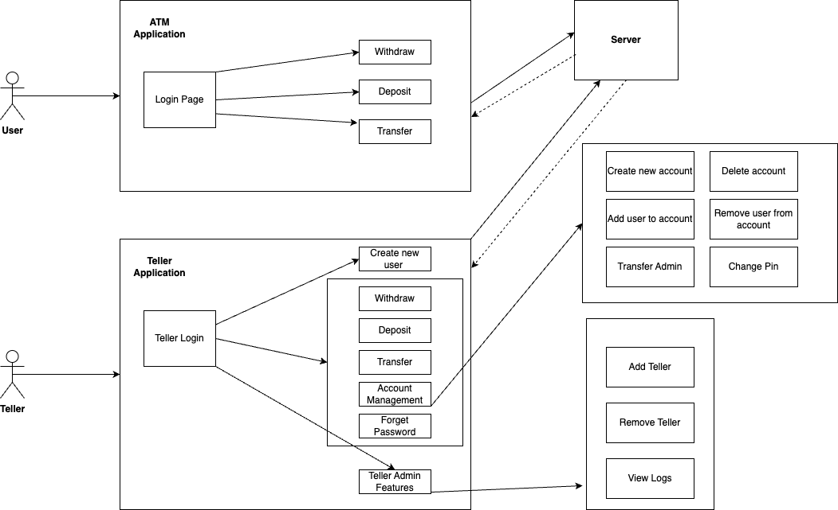

## Teller Use Case Diagram:

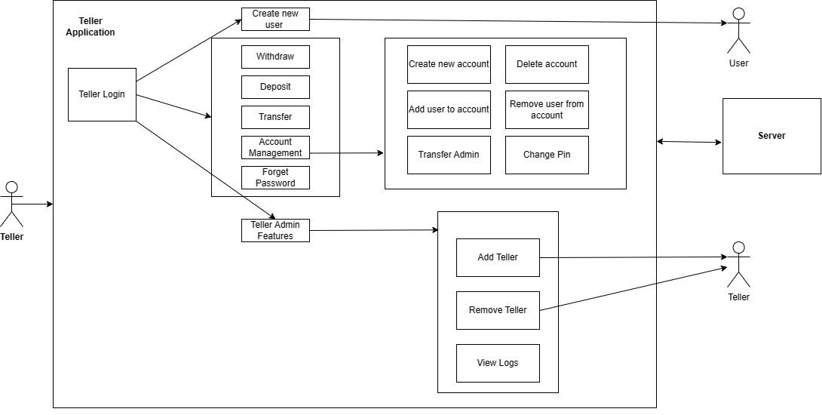

## ATM Use case Diagram:

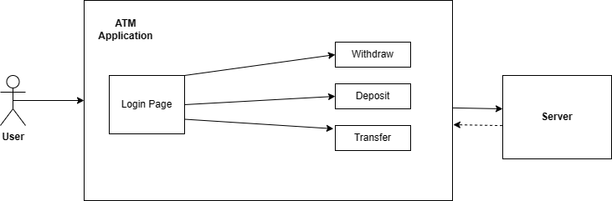

# 5. Sequence Diagrams

## ATM Transfer Money Sequence Diagram

# 

## ATM Withdraw Money Sequence Diagram

## Teller Create New User Sequence Diagram

## Teller Add User to Account

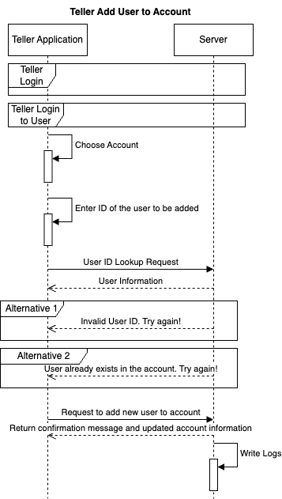

## Teller Change Pin

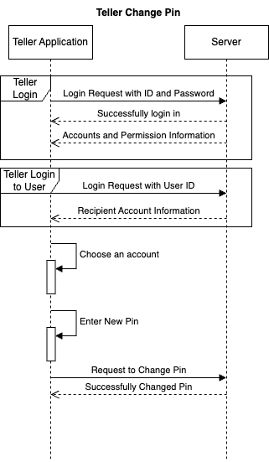

## Teller Create Account

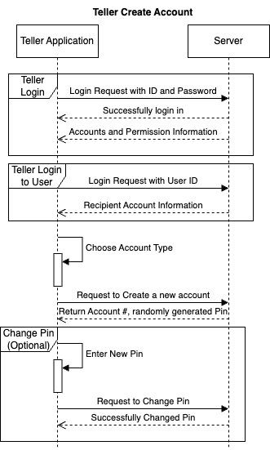

## Teller Delete Account

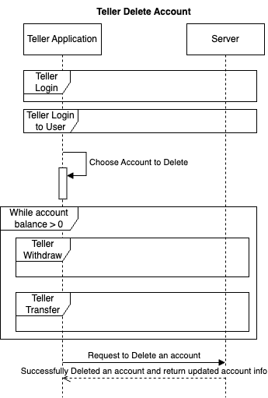

## Teller Remove User from Account

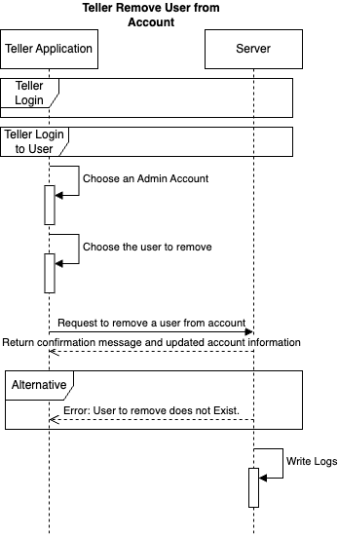

## Teller Rest User Password

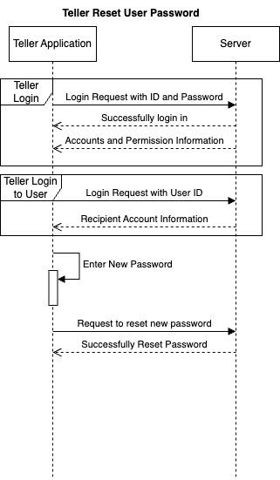

## Teller Transfer User Account Admin to Another

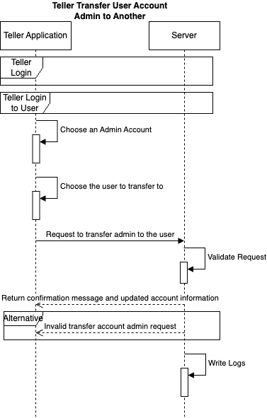

## Teller Admin Add Teller

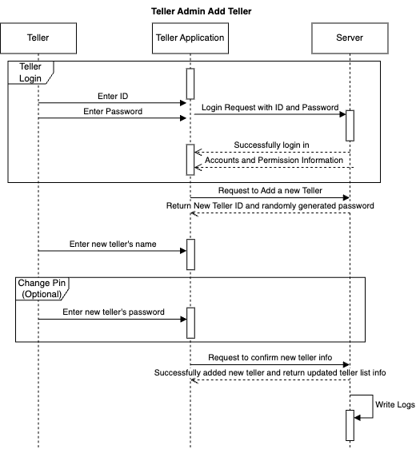

## 

# User Interface Design

## 1. ATM UI Design

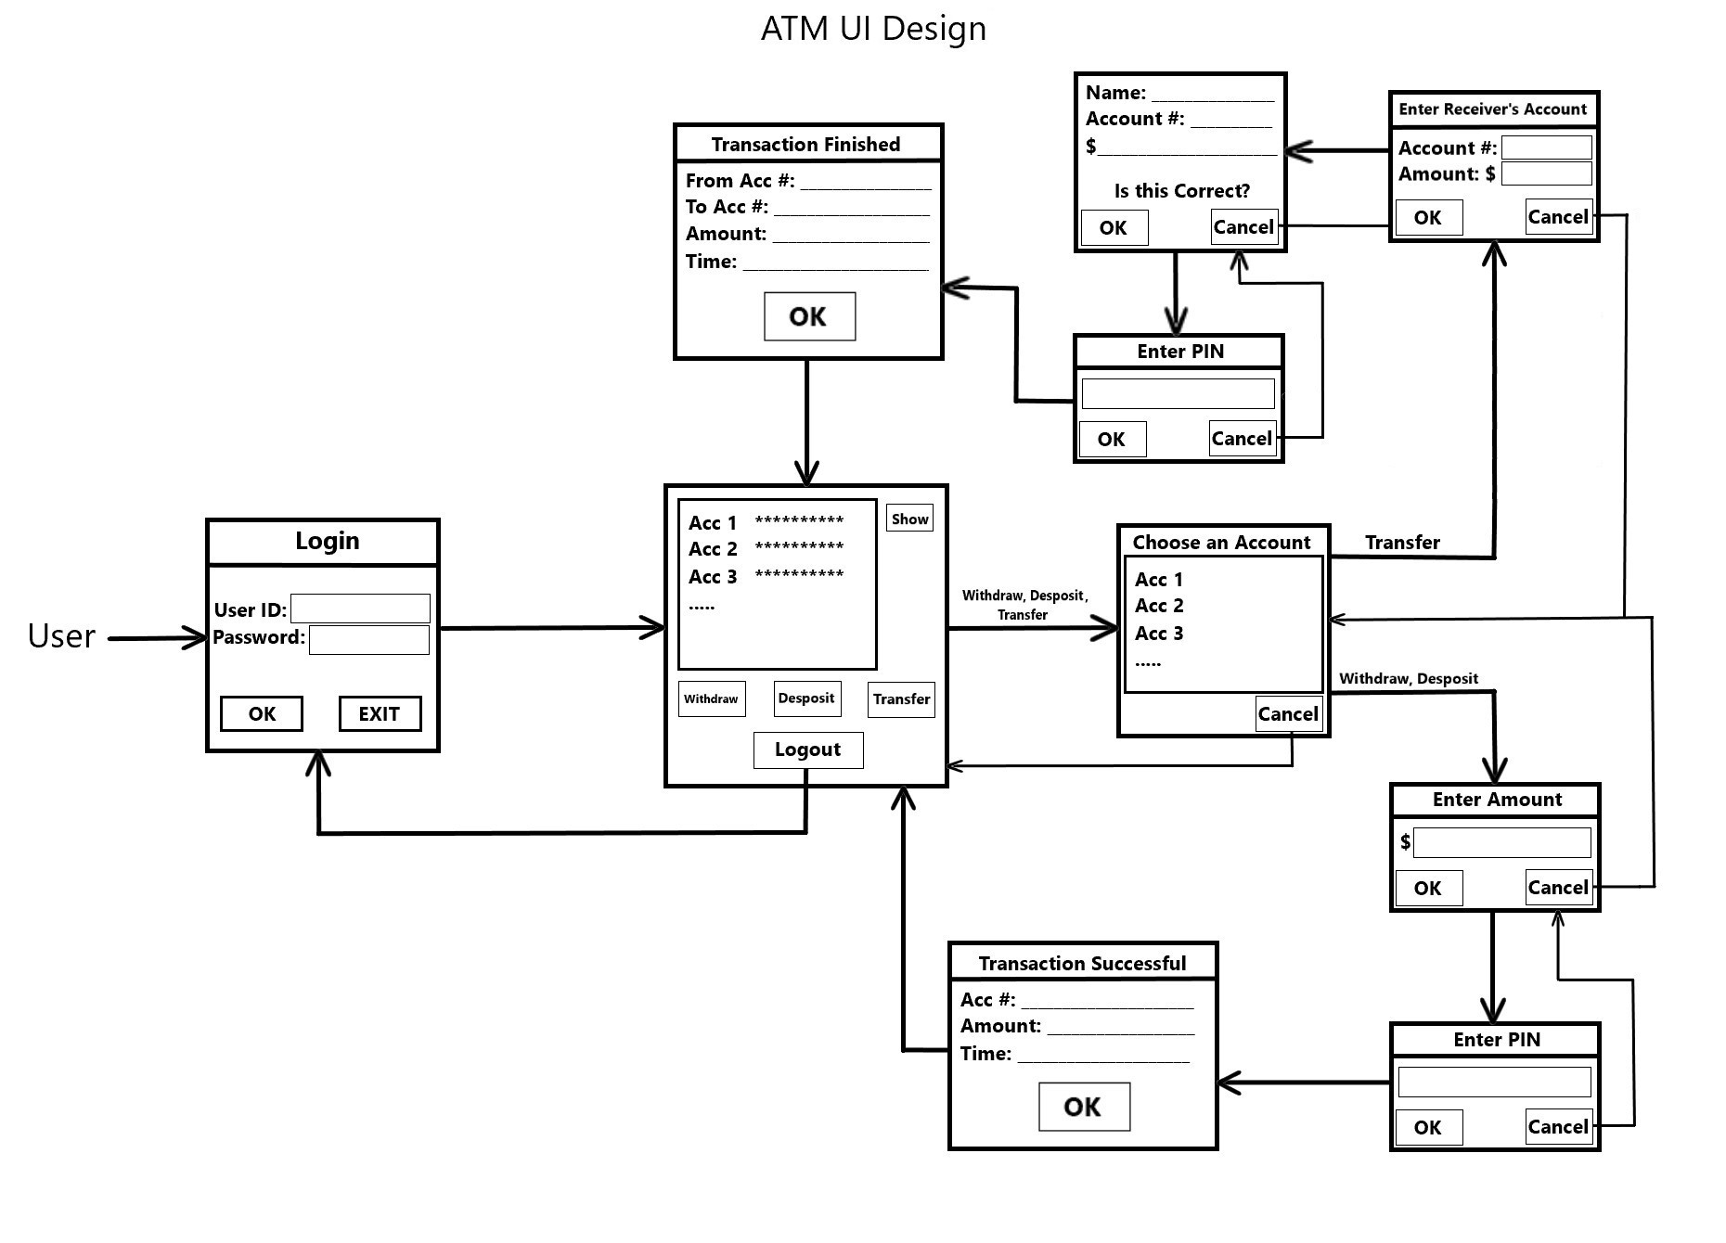

## 2. Teller application UI Design

